Return Distributions: Percentage Return Conversion

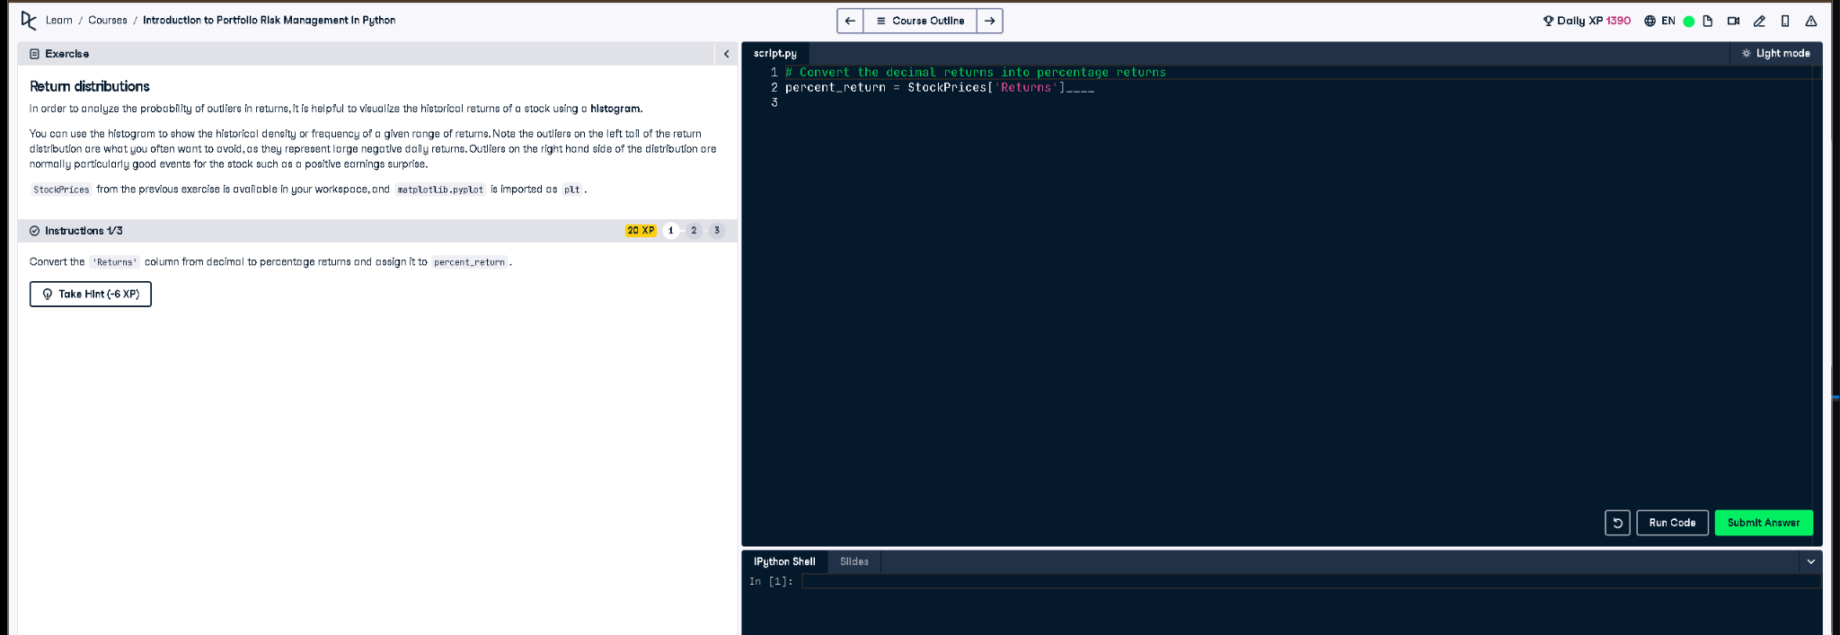

# Python Code

# Convert the decimal returns into percentage returns  
percent_return = StockPrices['Returns'] * 100

# Explanation

This code multiplies the 'Returns' column by 100 to convert daily returns from decimal format to percentage format. For example, a return of 0.01 (1%) becomes 1.0 when multiplied. This is useful for plotting or interpreting data more intuitively.